*Highlighted part is either note to internal team or content that needs to be replaced with correct values e.g. email addresses, dates, etc.*

Below is a complete AI Usage Disclaimer for SproutSong / SproutMentors, prepared for internal review, compliance tracking, and later website/app publication.

---

SproutSong / SproutMentors

AI Usage Disclaimer

Internal Review Draft for Compliance Tracking & Website Publication

Document Name: AI Usage Disclaimer
Platform: SproutSong / SproutMentors
Version: v1.0 Draft
Status: Draft — Legal Review Pending
Effective Date: To be added
Last Updated: To be added
Privacy Contact: privacy@sproutsong.com
Support Contact: support@sproutsong.com

---

Internal Review Checklist

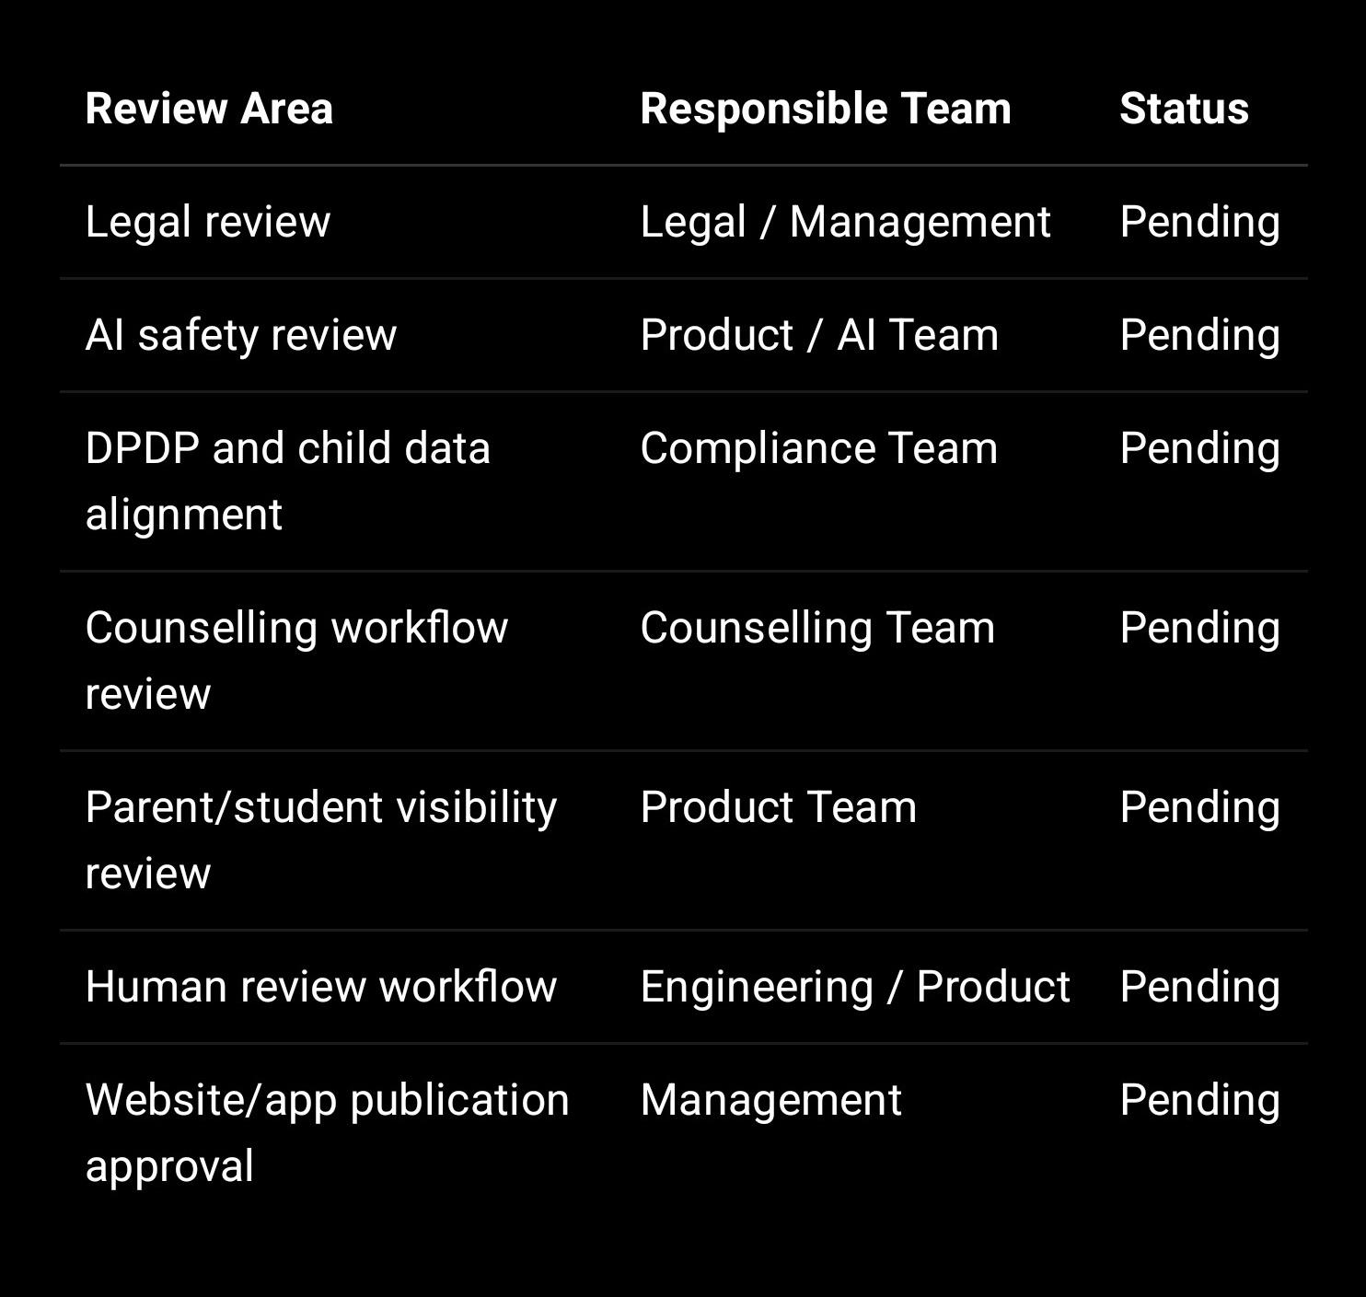

---

1. Purpose of This Disclaimer

SproutSong / SproutMentors may use AI-assisted tools to support educational, academic, counselling, reporting, and school management workflows.

This AI Usage Disclaimer explains:

What AI may be used for
What AI does not do
The limitations of AI-generated outputs
The need for human review
How AI outputs should be interpreted
How student safety is protected
How users can request correction or clarification

This disclaimer should be displayed wherever AI-generated or AI-assisted reports, summaries, predictions, recommendations, or dashboards are shown.

Your internal AI safety guidance already states that AI may be used for career guidance, academic performance analysis, counselling reports, learning recommendations, parent-ready summaries, and principal dashboard insights, but must minimise student data, avoid harmful labels, require consent, and require human review for counselling/career guidance.

---

2. What AI May Be Used For

SproutSong / SproutMentors may use AI-assisted tools for:

Career guidance support
Academic performance analysis
Counselling report preparation
Learning recommendations
Parent-ready summaries
Teacher support insights
Principal dashboard summaries
Class-level or school-level trend insights
Student progress summaries
Study improvement suggestions
Report drafting and formatting
Content summarisation
Administrative assistance

AI is used to assist authorised users, not to replace them.

---

3. What AI Does Not Do

AI does not:

Make final academic decisions
Make final career decisions
Replace teachers
Replace parents or guardians
Replace professional counsellors
Replace school authorities
Provide psychological diagnosis
Provide medical diagnosis
Guarantee exam results
Guarantee admission, scholarship, or career outcomes
Determine a student’s worth, ability, intelligence, or future success
Act as the sole basis for stream/course selection
Act as the sole basis for disciplinary action
Act as the sole basis for counselling conclusions

AI outputs are suggestions, summaries, drafts, or analytical support only.

---

4. Main Disclaimer Text for Website / App

Use this as the main user-facing disclaimer:

SproutSong / SproutMentors may use AI-assisted tools to generate educational insights, academic summaries, counselling support, learning recommendations, career guidance suggestions, parent-ready reports, and school dashboard insights.

AI-generated or AI-assisted outputs are provided for educational support only. They are not final decisions and should not be treated as professional, psychological, medical, legal, or career advice.

AI outputs may contain errors, incomplete interpretations, or recommendations that require human review. All important AI-generated reports or recommendations should be reviewed by an authorised teacher, counsellor, parent/guardian, school authority, or qualified professional before being used for academic, counselling, or career-related decisions.

SproutSong / SproutMentors does not use AI to label, judge, shame, or permanently categorise students. AI is intended to support learning, guidance, improvement, and student wellbeing.

---

5. Short Disclaimer for AI Reports

Use this inside each AI-generated report:

AI-Assisted Report Notice

This report includes AI-assisted insights generated from available academic, counselling, attendance, assessment, or learning-related data.

This report is for educational guidance only. It is not a final decision and does not replace the judgment of teachers, counsellors, parents, guardians, school authorities, or qualified professionals.

Please review this report carefully before making academic, counselling, stream-selection, or career-related decisions.

---

6. Parent-Facing Disclaimer

Use this when reports are shown to parents/guardians:

This report includes AI-assisted educational insights about your child. These insights are generated to support discussion with teachers, counsellors, and the school.

AI recommendations may not always be complete or accurate. They should not be used as the only basis for academic, counselling, stream-selection, or career decisions.

Please discuss the report with the student, teacher, counsellor, or school authority before taking any major decision.

---

7. Student-Facing Disclaimer

Use simpler, supportive language for students:

This guidance was created with the help of AI and reviewed for educational support.

It is not a final judgment about you or your future. It is meant to help you understand your strengths, improvement areas, and possible learning or career paths.

Please discuss this guidance with your parent, teacher, counsellor, or school before making any important academic or career decision.

---

8. Teacher / Counsellor Disclaimer

Use this inside the teacher/counsellor review panel:

This AI-generated output is a draft/supportive insight only.

Before sharing it with a student or parent, please review the content for accuracy, context, fairness, tone, and student wellbeing.

Do not approve AI output that contains harmful labels, unsupported conclusions, psychological/medical claims, or final academic/career decisions.

Teachers and counsellors remain responsible for human review and final guidance.

---

9. Principal / School Dashboard Disclaimer

Use this for school-level dashboards:

AI-assisted dashboard insights are intended to support school-level planning, academic improvement, and early support identification.

These insights should be interpreted as indicators, not final conclusions. Individual student-level action should be reviewed by authorised teachers, counsellors, parents, or school authorities.

Aggregated insights should not be used to unfairly label, rank, or negatively profile students, teachers, classes, or groups.

---

10. AI Prediction Safety Disclaimer

Use this wherever prediction or recommendation features are shown:

Prediction Safety Notice

AI-based predictions are based only on the data available in the platform and may not reflect the full context of a student’s life, ability, learning environment, motivation, health, family situation, or future potential.

Predictions should be treated as early indicators for support, not as fixed outcomes. A prediction does not mean that a student will succeed, fail, choose a certain stream, or follow a particular career.

All predictions must be reviewed by authorised human reviewers before being shared or acted upon.

---

11. Language That Must Be Avoided

AI outputs and human-reviewed reports should avoid harmful or final labels.

Do not use:

Weak student
Poor intelligence
Low potential
High failure risk
Not suitable for Science
Not suitable for Commerce
Bad learner
Will fail
Cannot do this stream
Poor mindset

Use safer alternatives:

The student may need additional support in...
Current indicators suggest exploring...
Recommended areas for improvement include...
The student shows stronger alignment with...
The student may benefit from...
This recommendation should be reviewed by a teacher/counsellor/parent.

Your internal AI guidance specifically instructs the team to avoid labels like “weak,” “failure risk,” and “low potential,” and use supportive alternatives such as “may need additional support” and “recommended areas for improvement.”

---

12. Human Review Requirement

AI-generated outputs should not be automatically shared with students or parents where the output affects academic, counselling, career, or student wellbeing decisions.

Human review is required for:

Career guidance reports
Counselling reports
Stream/course recommendations
Parent-ready summaries
Student risk/support indicators
Principal dashboard student-level insights
Reports containing behavioural or sensitive observations
AI-generated academic intervention suggestions

Suggested workflow:

AI Draft Generated
↓
Teacher / Counsellor Review
↓
Edit / Reject / Approve
↓
Approved for Parent / Student Visibility
↓
Audit Log Stored

Your previous AI safety framework recommends that AI outputs be stored as draft first, reviewed by teacher/counsellor, then separately approved for student/parent visibility. This aligns with your internal requirement that AI output should be reviewed before final use.

---

13. AI Consent Notice

Before AI-assisted analysis is used for student reports, counselling, or recommendations, show this consent notice:

I understand that SproutSong / SproutMentors may use AI-assisted tools to generate educational insights, academic summaries, counselling support, learning recommendations, career guidance suggestions, and parent-ready reports.

I consent to the use of the student’s academic, counselling, attendance, assessment, interest, and learning-related data for AI-assisted educational support purposes only.

I understand that AI output is assistive and not a final decision. AI-generated recommendations should be reviewed by a teacher, counsellor, parent/guardian, or authorised school representative before final use.

I understand that student data will not be used for targeted advertising or harmful profiling.

Checkbox:

☐ I consent to AI-assisted educational analysis and report generation.

For minors, this should be given by parent/lawful guardian or authorised school representative, depending on the workflow and DPA/consent arrangement.

---

14. Data Minimisation Statement

Use this in the policy and AI feature page:

SproutSong / SproutMentors aims to minimise the personal data used for AI-assisted processing.

Where possible, student identifiers such as full name, parent contact details, address, admission number, and unnecessary personal information are removed or replaced with limited references before AI processing.

AI processing should use only the data needed for the stated educational purpose.

Your internal guidance also requires minimising student data sent to AI APIs and removing identifiers wherever possible.

---

15. AI Output Accuracy Limitation

AI-generated content may be inaccurate, incomplete, outdated, biased, or unsuitable for a specific student context.

AI may not understand personal circumstances, emotional context, learning environment, family background, school-specific expectations, teacher observations, or recent events unless such data is accurately provided and lawfully processed.

Users should verify AI outputs with authorised teachers, counsellors, parents, or school authorities before relying on them.

---

16. No Professional Replacement Clause

AI-assisted outputs do not replace professional judgment.

SproutSong / SproutMentors AI tools do not replace:
• Teachers
• Parents/guardians
• Counsellors
• Principals
• School administrators
• Psychologists
• Doctors
• Legal or compliance professionals
• Career guidance professionals

Any important academic, counselling, medical, psychological, disciplinary, or career-related decision should be made by qualified humans after reviewing the student’s full context.

---

17. AI and Children’s Data

SproutSong / SproutMentors treats children’s data with special care.

AI should not be used to:
• Target children with advertising
• Negatively profile students
• Make final decisions about a child
• Create harmful labels
• Publicly rank or shame students
• Infer sensitive attributes unnecessarily
• Replace parent, teacher, counsellor, or school judgment

AI should be used only to support learning, guidance, improvement, and student wellbeing.

Your internal child data and AI guidance says children’s data should not be used for targeted advertising, harmful profiling, or negative labelling, and AI should not make final decisions about a child.

---

18. AI Report Visibility Rules

AI reports should follow strict visibility controls.

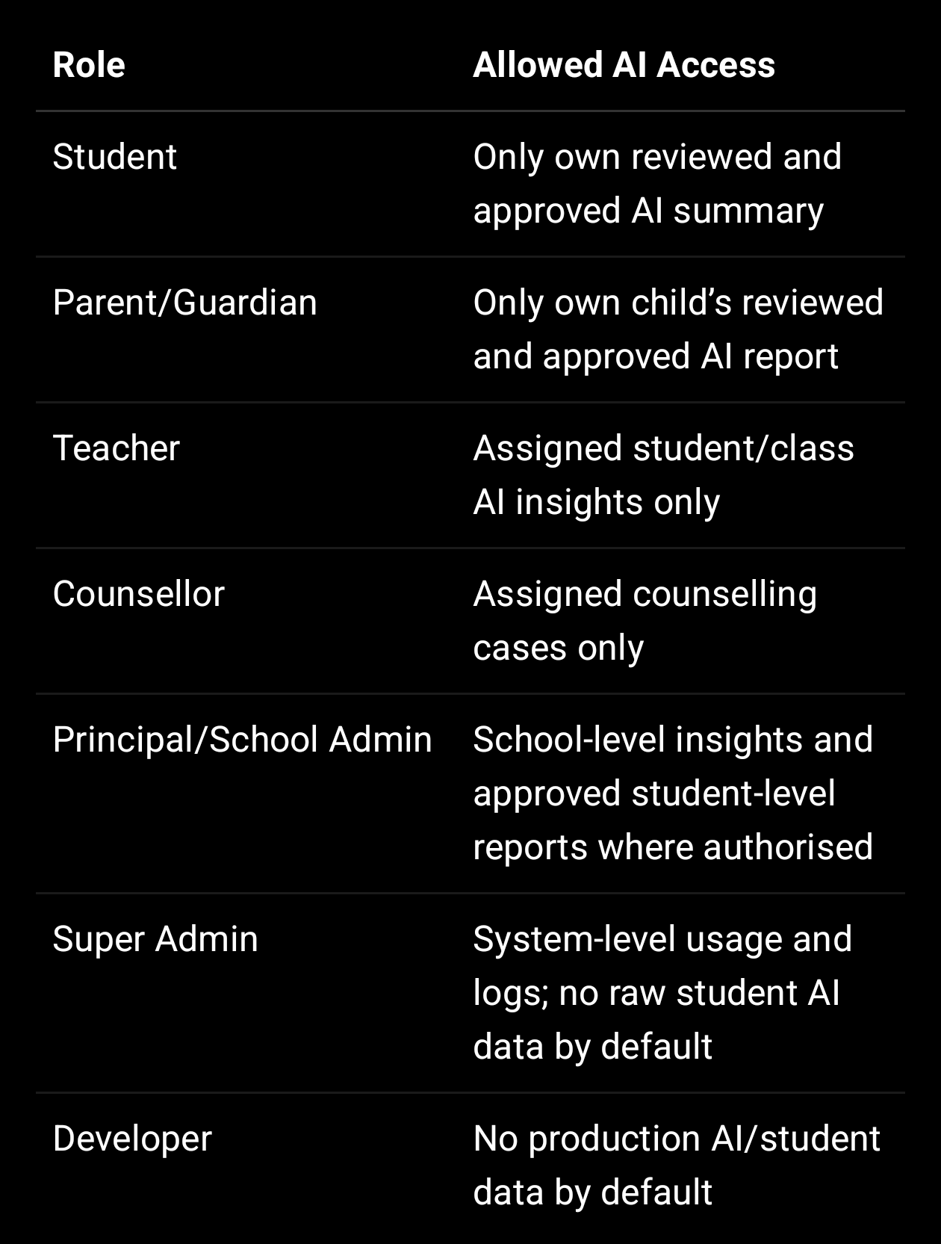

AI outputs should not be visible to students/parents until:

humanReviewed = true
visibleToStudent / visibleToParent = true
schoolId matches
user is linked to the student
consent exists

---

19. AI Assistance Level Notice

If the platform shows whether a report is AI-generated or human-edited, use this explanation:

AI Assistance Level explains how much AI was used in preparing this report.

Examples:
• Human-written: No AI assistance
• Light AI assistance: AI helped with grammar, formatting, or summary
• Moderate AI assistance: AI helped draft some sections and a human edited them
• High AI assistance: AI generated most of the draft and a human reviewed it
• AI-generated draft: AI created the initial draft and it requires human review

AI Assistance Level is not a judgment of quality. It only explains how the content was prepared.

---

20. Correction and Challenge Rights

Users should be able to request correction of AI-generated outputs.

If a parent, student, teacher, or school believes an AI-assisted report is incorrect, incomplete, unfair, harmful, or misleading, they may request review or correction.

Requests can be submitted to:
privacy@sproutsong.com
support@sproutsong.com

Internally, create a workflow:

AI Report Correction Request
↓
Verify requester
↓
Assign reviewer
↓
Review report and source data
↓
Correct / reject / regenerate
↓
Notify requester
↓
Audit log closure

---

21. AI Processing Log Requirement

Every AI generation event should be logged internally.

Recommended fields:

{
schoolId,
studentId,
requestedBy,
requestedByRole,
module,
purpose,
inputDataFields,
anonymized,
personalIdentifiersRemoved,
provider,
model,
promptHash,
rawPromptStored: false,
outputRecordId,
aiAssistancePercent,
humanReviewed,
reviewedBy,
reviewedAt,
visibleToStudent,
visibleToParent,
consentRefId,
ipAddress,
userAgent,
createdAt
}

Do not store raw prompts containing unnecessary student PII unless there is a clear purpose, strict access control, and short retention.

---

22. Backend Visibility Check Example

function canViewAiReport(user, report) {
if (String(user.schoolId) !== String(report.schoolId)) {
return false;
}

if (user.role === "student") {
return (
String(user.linkedProfileId) === String(report.studentId) &&
report.visibleToStudent === true &&
report.humanReviewed === true
);
}

if (user.role === "parent") {
return (
user.childIds.map(String).includes(String(report.studentId)) &&
report.visibleToParent === true &&
report.humanReviewed === true
);
}

if (user.role === "teacher") {
return user.assignedStudentIds
.map(String)
.includes(String(report.studentId));
}

if (user.role === "counsellor") {
return user.assignedCounsellingStudentIds
.map(String)
.includes(String(report.studentId));
}

if (["principal", "school_admin"].includes(user.role)) {
return String(user.schoolId) === String(report.schoolId);
}

return false;
}

---

23. Website Version — AI Usage Disclaimer Page

Use this shorter published version:

SproutSong / SproutMentors may use AI-assisted tools to support educational guidance, academic analysis, counselling report preparation, learning recommendations, parent-ready summaries, and school dashboard insights.

AI outputs are provided for educational support only. They are not final decisions and do not replace teachers, counsellors, parents, school authorities, or qualified professionals.

AI-generated content may be inaccurate, incomplete, biased, or unsuitable for a specific student context. Important decisions about academics, stream selection, counselling, student wellbeing, or career planning should always involve human review.

SproutSong does not use AI to label, shame, negatively profile, or permanently categorise students. AI should support learning, improvement, and student wellbeing.

Where possible, SproutSong minimises personal identifiers before AI processing. AI outputs affecting students should be reviewed before being shared with students or parents.

For concerns, corrections, or questions about AI-assisted reports, contact privacy@sproutsong.com or support@sproutsong.com.

---

24. Short Inline Disclaimer for Every AI Feature

Use this small text under AI-generated sections:

AI-assisted insight. For educational support only. Requires human review before final use.

For reports:

This report includes AI-assisted content. It should be reviewed by a teacher, counsellor, parent, or school authority before making academic or career decisions.

For dashboards:

AI dashboard insights are indicators only and should not be used to unfairly label, rank, or profile students.

---

25. Internal Compliance Tracking Fields

Store this disclaimer in your compliance documents collection:

{
documentType: "AI_USAGE_DISCLAIMER",
version: "v1.0",
title: "SproutSong / SproutMentors AI Usage Disclaimer",
status: "PUBLISHED",
effectiveDate: "YYYY-MM-DD",
publishedUrl: "https://www.sproutsong.com/ai-usage-disclaimer",
approvedBy: "Management / Legal / Compliance",
approvedAt: "YYYY-MM-DDTHH:mm:ssZ",
linkedPrivacyPolicyVersion: "v1.0",
linkedConsentPolicyVersion: "v1.0",
linkedChildDataPolicyVersion: "v1.0",
changeSummary: "Initial published version",
createdAt: Date,
updatedAt: Date
}

---

26. Final Implementation Checklist

Before publishing and enabling AI features:

1. Add AI Usage Disclaimer page.

2. Add short AI disclaimer inside every AI report.

3. Add AI consent checkbox before AI analysis.

4. Require parent/guardian consent for minors.

5. Add AI processing logs.

6. Remove unnecessary student identifiers before AI processing.

7. Disable raw prompt logging unless strictly required.

8. Add human review workflow.

9. Add approved visibility controls for parent/student.

10. Add harmful-label safety filter.

11. Add correction request process.

12. Add AI report audit logs.

13. Add AI Assistance Level badge if reports are generated/edited through AI.

14. Train teachers/counsellors on reviewing AI outputs.

15. Link disclaimer with Privacy Policy, Consent Policy, Child Data Protection Policy, and Terms.

---

Final Internal Note

This AI Usage Disclaimer should be published together with:

Privacy Policy
Terms & Conditions
Child Data Protection Policy
Consent Policy
Data Retention Policy
School Data Processing Agreement
Breach Response Policy
Cookie Policy, if cookies/analytics are used

Your internal readiness guide already lists AI usage, student prediction safety, consent, human review, and child-safe AI language as part of the required DPDP/security governance package.

